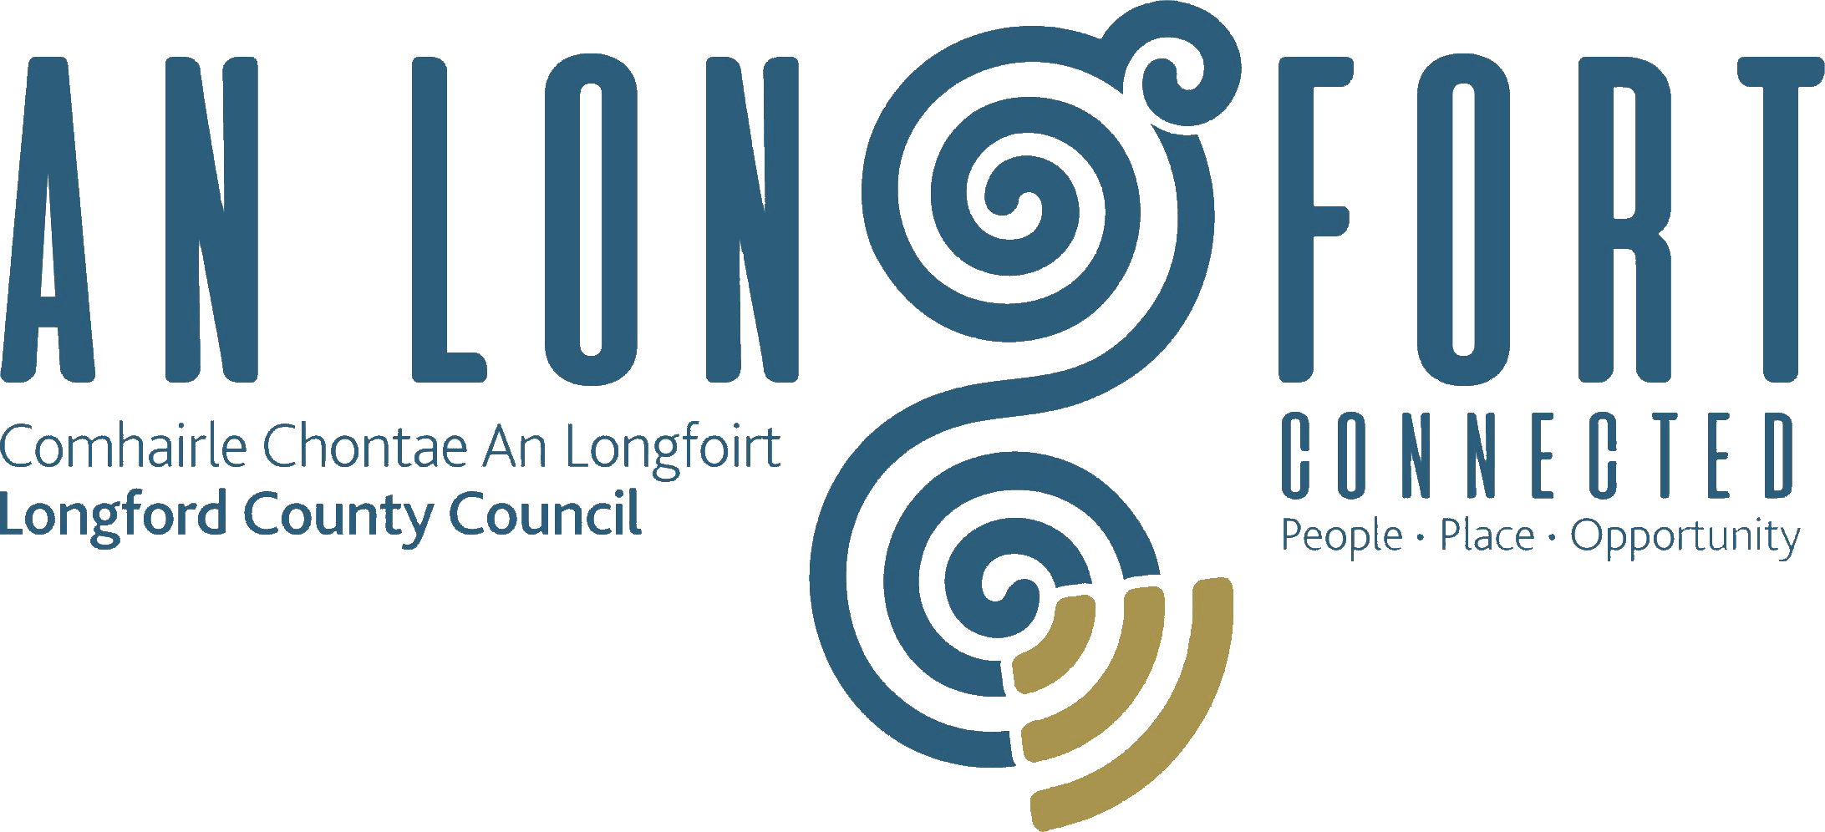

BALLYMAHON MUNICIPAL DISTRICT

Minutes of Meeting of Ballymahon Municipal District held in the Council Chamber,
Aras an Chontae, Longford on Thursday, 24th October 2019 at 4.30 p.m.

CATHAOIRLEACH: Councillor Pat O’Toole

MEMBERS PRESENT: Councillors – Mick Cahill, Colm Murray,
Gerard Farrell and Paul Ross.

IN ATTENDANCE: Mr. John McKeon, Head of Finance.
Ms. Barbara Heslin, Director of Services.
Ms. Linda Higgins, Administrative Officer.
Mr. Paul Newell, Senior Executive Engineer.

APOLOGIES: Councillor Mark Casey.

MEETINGS
ADMINISTRATOR: Ms. Anne Lee.

2020 GENERAL MUNICIPAL ALLOCATION.

John McKeon gave a comprehensive presentation on the 2020 General Municipal Allocation.

John confirmed that monies which had been allocated from each Municipal District General Municipal Allocation for Tourism Promotion, Environmental & Climate Change Initiatives and Burial Grounds will, in future, be allocated from the Local Authority central budget.

John also referred to the decision taken by the members in September that the basic rate of local property tax should stand varied upwards by 15% for the year 2020 which will be -
- allocated to service loans to match fund capital projects.
- ringfence and retain any LPT variation monies each year to be spent specifically on
Capital Projects and to be used as matched funding for strategic projects.
- General Municipal Allocation to 2018 levels – to be used in conjunction with Members Countywide Fund.

On the proposal of Councillor C. Murray seconded by Councillor M. Cahill, it was unanimously agreed to adopt the 2020 General Municipal Allocation, as detailed by
John McKeon.

This concluded the business of the meeting.

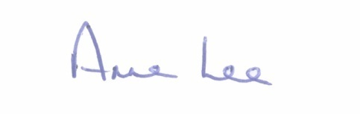

Signed: ____________________
Anne Lee,
Meetings Administrator.

Confirmed and adopted at Longford Municipal District Meeting held on the
9th December 2019.

Signed: _______________
Cathaoirleach.

